$ df -h

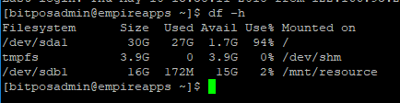

you'll notice that /dev/sda1 size didn't change YET.   
Don't worry, that's normal, since we still need to increase the partition size on Linux, so that it can span the new size increase, and it perfectly makes sense !!  
 **2) Increase the Partition on the Linux OS level**Connect to the machine through SSH, or open the command terminal

$ sudo fdisk /dev/sda

Type "u"  
Type "p" to list the partition details  
Type "d" to delete the partition, don't worry this will not delete the data, it will alter the partition, then select the partition  
Type "n" to create a new partition  
Type "p" to create a primary partition  
Type "1" to create the first partition and accept the default sector to use the entire disk

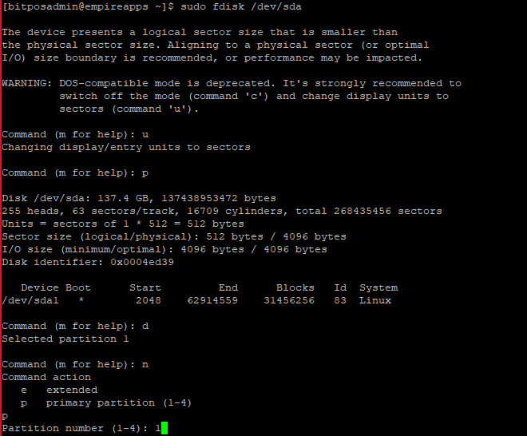

First sector should always be 2048 and last sector can be default.

Screen Clipping

Type “a” and select partition 1 to mark the boot partition as active. Type “p” to to ensure all settings are correct:

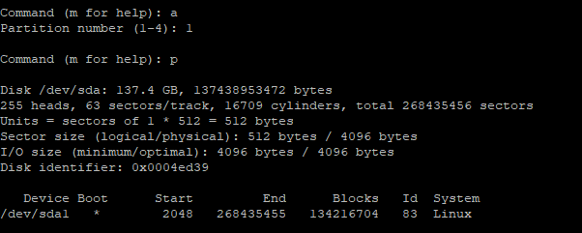

Type "w" to write these changes

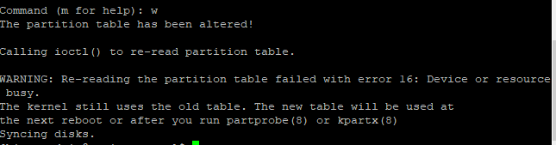  
You will get a warning that says: *WARNING: Re-reading the partition table failed with error 16: Device or resource busy.* This is fine.

Reboot

sudo reboot

Once the VM is up and running, login to your Azure VM using SSH   
Resize the file system by typing:

$ sudo resize2fs /dev/sda1

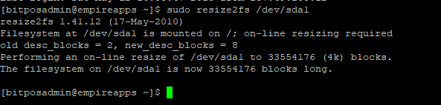

**Verify**

df -h

Now /dev/sda1 should have the new increased size.

